Exp 4: Data modelling and form design for a business application in Zoho Creator.
241401127

1. Aim
To design and build a functional "Bank Loan Application Form" application in Zoho Creator that demonstrates the correct usage of all thirteen Basic Fields available in the Form Builder, while solving a real banking requirement of collecting and pre-screening loan applications submitted by prospective borrowers.

2. Procedure

2.1 Problem Statement & Application Scope
A bank branch currently accepts loan applications through paper forms filled at the counter, leading to illegible handwriting, incomplete income details, and delays in routing applications to the correct loan officer based on loan type. There is no digital pre-screening step before the applicant is called in for document verification.
Design a low-code application using Zoho Creator that allows a prospective borrower to submit a loan application enquiry through a single online form. The form must capture personal identity, contact details, employment and income details, loan requirements, existing liabilities, and consent for a credit check — using every Basic Field type provided by Zoho Creator's Form Builder.
- Application Name: Loan Application & Pre-Screening Management
- Form Name: Loan_Application_Form
- Primary Users: Prospective borrowers / Bank loan officers
- Report View: Loan_Application_Form Report (list of all submitted loan applications)
- Objective of the Report: Enable loan officers to filter, pre-screen, and route applications for document verification and approval

2.2 Data Model & ER Diagram
A Data Model consists of both the visual Entity-Relationship (ER) diagram showing schema relationships and the structured Data Dictionary table defining field types and constraints. The structure below illustrates the internal schema generated by Zoho Creator for Loan_Application_Form, showing the primary form entity, composite data structures, system metadata fields, and choice lookup sets.
APPLICANT_INFO (Composite)
- First_Name : String
- Last_Name : String
- Email_Address : Email
- Contact_Number : Phone
- Residential_Address : Address
LOAN_REQUEST (Entity)
- [PK] PAN_Number : String
- Loan_Type : Dropdown
- Monthly_Income : Number
- Purpose_Of_Loan : Text
LOAN_APPLICATION_FORM (Form Entity)
- [PK] ID : BigInt (Auto-Generated)
- Applicant_Name : Name [Composite]
- Email_Address : Email (RFC 5322)
- Contact_Number : Phone (+91)
- Residential_Address : Address [Comp]
- PAN_Number : Text [Single]
- Date_Of_Birth : Date
- Employment_Type : Radio [Enum]
- Monthly_Income : Number
- Existing_Liabilities : List [Multi]
- Loan_Type : Picklist [Enum]
- Purpose_Of_Loan : TextArea
- Preferred_Callback_Time : Time
- Consent_For_Credit_Check : Checkbox [Bool]
EMPLOYMENT_TYPE_CHOICES : Salaried | Self-Employed
LOAN_TYPE_CHOICES : Home Loan | Personal Loan | Business Loan | Auto Loan | Education Loan
EXISTING_LIABILITIES_CHOICES : Car Loan | Personal Loan | Credit Card Dues | Education Loan | None
Figure 1: Entity-Relationship (ER) Schema Structure for Loan Application Form in Zoho Creator

2.3 Basic Fields Mapping & Data Dictionary
Table 1 presents the mapping of all thirteen Basic Fields from the Zoho Creator Form Builder palette to their specific roles, purpose, and sample values in Loan_Application_Form.
Basic Field | Form Field Name | Field Link Name | Purpose & Validation Constraints | Sample Value
Name | Applicant Name | Applicant_Name | Captures full name of applicant using First/Last name sub-fields (Mandatory). | Suresh Raghavan
Email | Email Address | Email_Address | Captures a validated email address for sending application status updates. | suresh.raghavan@example.com
Address | Residential Address | Residential_Address | Captures the applicant's full residential address with city, state, and pincode. | 18, Lake View Road, Trichy, TN, 620001
Phone | Contact Number | Contact_Number | Captures a validated mobile number for the bank to call and verify details. | +91 94430 22110
Single Line | PAN Number | PAN_Number | Captures a short free-text entry for the applicant's PAN. | ABCDE1234F
Multi Line | Purpose of Loan | Purpose_Of_Loan | Captures free-text description of the intended use of the loan amount. | Funds required for home renovation and furniture purchase.
Number | Monthly Income | Monthly_Income | Captures numeric value for gross monthly income. Constraint: must be > 0. | 55000
Date | Date of Birth | Date_Of_Birth | Captures the applicant's date of birth using a date picker; used for age/eligibility checks (18+). | 22-Jan-1990
Time | Preferred Callback Time | Preferred_Callback_Time | Captures the applicant's preferred time slot for a callback from the loan officer. | 5:00 PM
Drop Down | Loan Type | Loan_Type | Presents a single-select list of loan products offered by the bank. | Home Loan
Radio | Employment Type | Employment_Type | Captures a single mandatory selection among mutually exclusive employment categories. | Salaried
Multi Select | Existing Liabilities | Existing_Liabilities | Allows selection of one or more existing loans or financial commitments held by the applicant. | Car Loan, Credit Card Dues
Checkbox | Consent for Credit Check | Consent_For_Credit_Check | Captures the applicant's consent for the bank to perform a credit bureau check. | Checked (Agreed)
Table 1: Mapping and Specification of Thirteen Basic Fields in Loan_Application_Form

2.4 Form Layout & Configuration Steps
The Loan_Application_Form was organized into four logical, applicant-friendly sections:
- Section A — Personal Details: Applicant Name (Name), Date of Birth (Date), PAN Number (Single Line).
- Section B — Contact Details: Email Address (Email), Contact Number (Phone), Residential Address (Address).
- Section C — Income & Employment Details: Employment Type (Radio), Monthly Income (Number), Existing Liabilities (Multi Select).
- Section D — Loan Details & Consent: Loan Type (Drop Down), Purpose of Loan (Multi Line), Preferred Callback Time (Time), Consent for Credit Check (Checkbox).
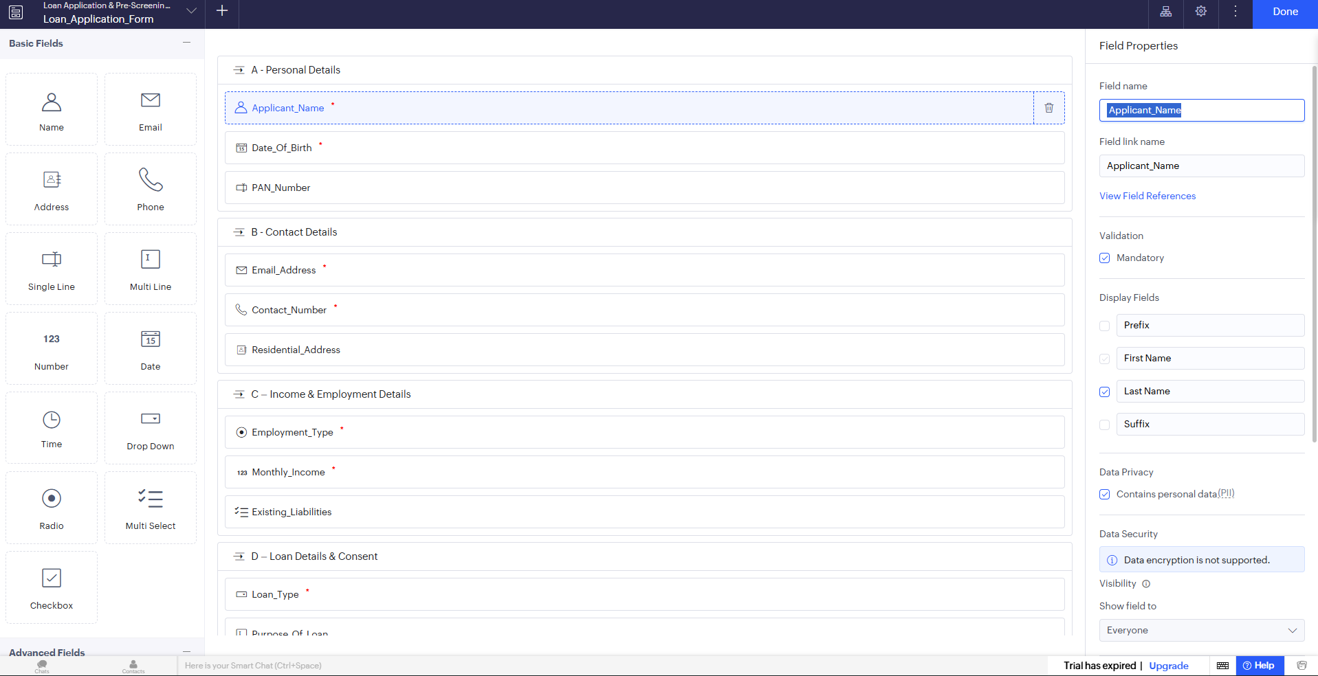
Figure 2: Form Builder Workspace & Field Properties Inspector Setup in Zoho Creator

2.5 Workflow Scripting Configuration
Field-level validations were configured directly on the form under Field Properties > Validation to enforce business logic checks: Applicant Name, Contact Number, Date of Birth, Employment Type, Loan Type, Monthly Income, and the Consent Checkbox were set as mandatory; the Email field's built-in RFC 5322 format validation was enabled; the Phone field's Indian country-code format was enabled; the Monthly Income field was restricted to values greater than 0; the Date of Birth field was restricted so the applicant must be at least 18 years old; and the form was configured so it cannot be submitted unless the credit-check consent checkbox is checked.

3. Output
The following figures show the live preview of the form and the submitted applicant record in the report view:
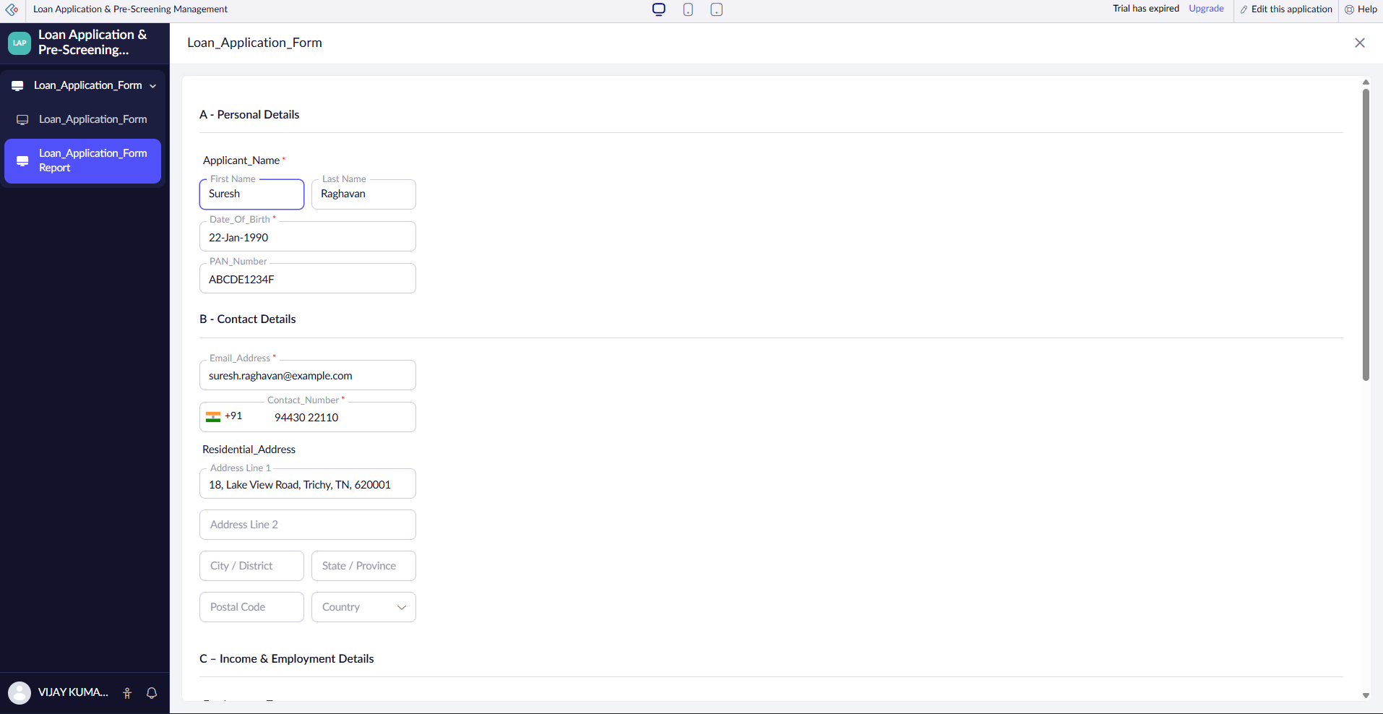
Figure 3: Live Application Runtime Preview for Loan_Application_Form Entry
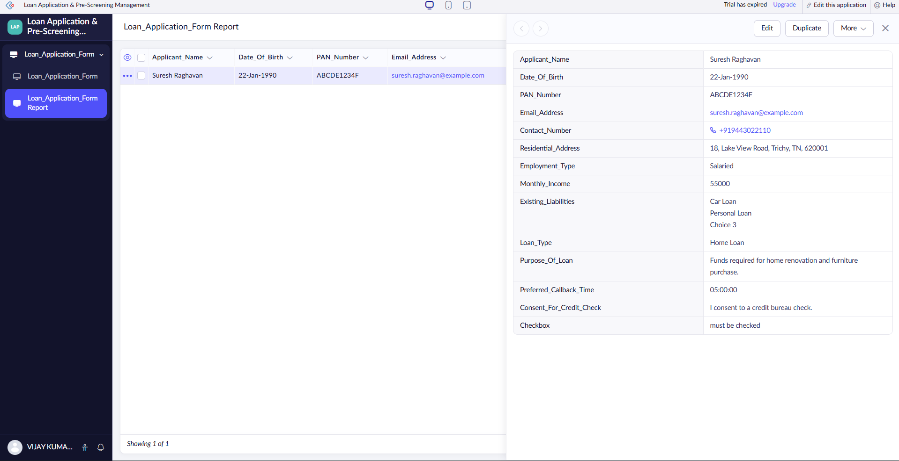
Figure 4: Loan_Application_Form Report View Displaying a Submitted Applicant Record

4. Result
The "Bank Loan Application Form" application was successfully built in Zoho Creator using all thirteen Basic Fields, with full field validations, section layout formatting, ER schema modeling, and report view generation meeting all assignment requirements.

